Trent D Albright M.D.
89 E Wilson Bridge Rd
Worthington, OH 43085
614-885-8833

PATIENT INFORMATION FOR BEFORE & AFTER CATARACT SURGERY
ABOUT THE PROCEDURE
Cataracts are part of the normal aging process. Most people over the age of 65 will have some degree of cataract development. A cataract occurs when the natural lens of the eye becomes cloudy. As the cataract develops, vision becomes blurry and colors may become distorted. Patients find that many of their daily activities such as driving and reading become more difficult.
The visual problems associated with a cataract cannot be corrected with a new eyeglasses prescription, topical medications or laser treatment. Surgery is necessary to remove the natural lens and replace it with a new, artificial lens to restore your vision.
Cataract surgery is one of the safest and most successful procedures performed. The surgery is an outpatient procedure performed using a topical anesthetic. Patients typically experience minimal discomfort and notice an improvement in their vision within a short period of time.
PREPARING FOR SURGERY
After Dr. Albright has completed your cataract evaluation, you will be contacted regarding the date and time of your cataract surgery. In some cases it may be necessary to return to the clinic to take further measurements and complete additional paperwork; this appointment will be scheduled for you if need be.
Prescription eye drops will be prescribed for you, and will need to be picked up from the pharmacy of your choice.
Your surgery will be performed at the 262 Neil Avenue Columbus, Ohio 43215. The surgery center will telephone you the day prior to your surgery to inform you of your arrival time, and any further instructions they have for you.
DAY OF SURGERY
- DO NOT HAVE ANYTHING TO EAT OR DRINK THE MORNING OF YOUR SURGERY. Fasting should begin at midnight the day prior to your surgery.
- You may take your regularly scheduled medications for heart conditions and high blood pressure (except for any diuretics) with a small sip of water. Do NOT take any other medications, especially insulin and oral diabetic medications.
- Wear simple, comfortable clothing to the surgery center. Shirts or blouses should have short sleeves and button-up fronts.
- Female patients: Avoid wearing facial cosmetics.
- You should expect to be at the surgery center for a few hours. Arrange to have a family member or friend take you home following the surgery.
WHAT TO EXPECT
Upon arriving at the surgery facility, you will be escorted to a pre-operative area. At this time a nurse will take a brief health history, obtain your vital signs and start an intravenous (IV) line. The IV will be used for the anesthesiologist to administer a mild sedative to make you feel sleepy. You will be awake during the procedure and alert enough to follow directions by the surgeon. The eye is numbed with a topical anesthetic. The entire procedure takes approximately 15 minutes.
After you leave the surgical suite, you will be taken to the recovery area where a nurse will ensure your comfort and make certain your vital signs are stable. Once discharge orders are completed, you will be allowed to return home with your family member or friend.

POST-OPERATIVE INSTRUCTIONS
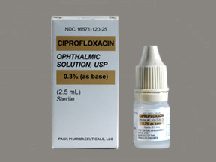
- Ciprofloxacin or Ciloxan (beige top), this is an antibiotic. You should use it in the operative eye 4 times daily starting the day of your surgery and continue for one week after surgery.
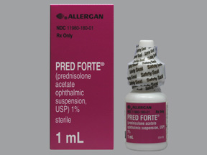
- Pred Forte or Prednisolone (commonly a pink top or pink label), this is a steroid medicine that reduces inflammation in the eye. Start the medicine the day of your surgery and use it 4 times a day for the first week.
    - Use it three times a day the second week
    - Use it two times a day the third week
    - Use it once daily the fourth week
    - After the fourth week it may be stopped
Should you happen to run out of the medicine prior to completing the entire taper it will be ok to stop it.
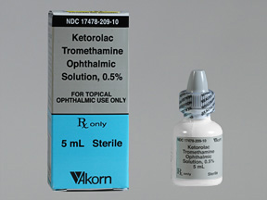
- Ketorolac (grey top), this is an anti-inflammatory medicine that helps to reduce post-operative inflammation and pain, it should be used 4 times daily and continued for 2 weeks after your surgery.
- You will be given a clear shield to be worn for 1 week after surgery while sleeping.
If you use any other prescription eye drops for glaucoma or dry eye, continue using these as well.
You may take over-the-counter pain relievers such as Tylenol for minimal discomfort or pain.
You will have a 1 day post-operative appointment scheduled with Dr. Albright at Worthington Ophthalmology. Additional post-operative appointments will be scheduled with either Dr. Albright or your optometrist.
In most cases you will be able to resume many of your normal activities. Take caution to keep the eye dry and clean and avoid bumping or pressing on the eye. Driving may be resumed once your doctor has established that your vision meets state requirements. If you have any questions or concerns regarding resuming activities, please do not hesitate to ask your doctor or the surgery coordinator.
When outside, dark sunglasses may help to reduce light sensitivity.
An eyeglass prescription will be provided 3-4 weeks after your surgery. If you require eyeglasses for reading or close work, over the counter reading glasses are usually sufficient. These can be purchased in many drug stores, supermarkets and discount stores without a prescription.
WHEN TO CALL THE OFFICE
- If at any time following the surgery you should experience sudden and dramatic increased eye pain, decreased vision or flashes and floaters call the office immediately at (614) 885-8833
- If you should notice an increase in soreness or light sensitivity 1 to 3 weeks following the surgery, call the office at (614) 885-8833
- If you have any questions or concerns about your recovery or progress, please do not hesitate to telephone the office at (614) 885-8833 for advice or reassurance.

